Precession of Mercury

The goal of my project was to simulate the precession of Mercury and graph the change in it’s angle of precession as the value of alpha is increased. Alpha was the primary parameter in my simulation as it is used in the calculation of the gravitational force vector applied on Mercury, $F_{g}≈\frac{G M_{S M_{M}}}{r^{2}}(1+ \frac{α}{r^{2}})$, and therefore alters the acceleration of Mercury as it orbits the sun. To model Mercury’s orbit around the sun I defined its initial position and velocity and incremented their value every time step by calculating the acceleration due to gravity using the gravitational force. As I altered the position of Mercury I also calculated its angle of precession with regards to the Sun. After Mercury orbits the Sun for one complete orbit, I incremented the value of alpha, subtracted the current angle of precession from the angle of precession of the previous orbit, found the slope of the line of best fit (using the least squares fit) for the change in the angle of precession over time, and graphed it. The simulation repeats until it reaches the maximum given alpha value and then displays the graph below.

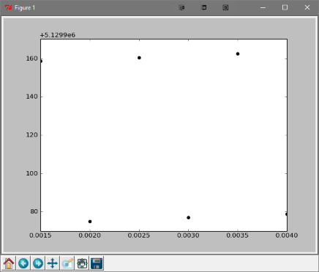

I unfortunately did not produce accurate results because I had some difficulty modeling the precession. Due to not being able to model the precession properly, the angles of precession are not accurate and my graph is misrepresentative of the phenomenon. Despite not obtaining the desired results, I did learn a lot about linear algebra and elliptical orbits while doing this project.